FCN Practical 4

Aim: -
Design and test a full-scale network for a company with multiple
branches and departments. Ensure smooth communication between all
parts of the organization and closely observe how information flows
across the network in different directions and through different paths.

Theory: -
A company with multiple branches and departments requires a hierarchical network design to ensure scalability, security, and efficient communication.
- LANs (Local Area Networks): Each branch and department has its own LAN, managed by switches.
- WAN (Wide Area Network): Routers connect branches together via technologies like MPLS, VPN, or leased lines.
- Core Network: At the head office, a core router or data center ensures centralized services (servers, databases, applications).
- Routing Protocols: Dynamic protocols (OSPF, EIGRP, BGP) enable communication across multiple paths.
- Security: Firewalls, VLANs, and access control lists (ACLs) safeguard inter-department and inter-branch communication.
Information flows in multiple directions:
- Within a department (intra-LAN).
- Between departments (inter-VLAN).
- Between branches (via WAN routing).
- Between branch and head office (WAN ↔ core network).
Testing involves ping, traceroute, file sharing, VoIP calls, and monitoring tools to observe how data takes different routes.
Output: 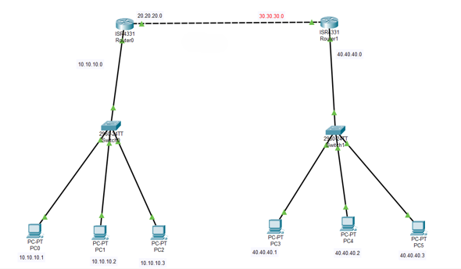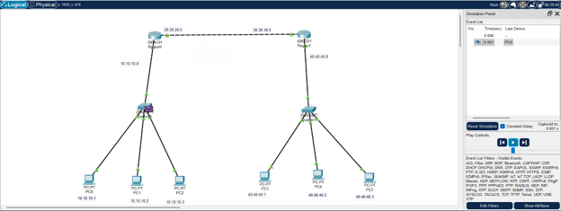

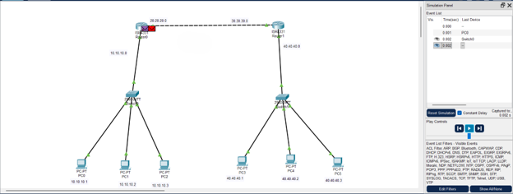

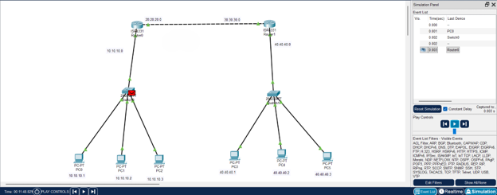

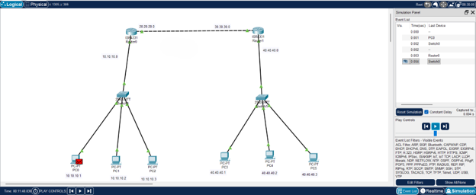
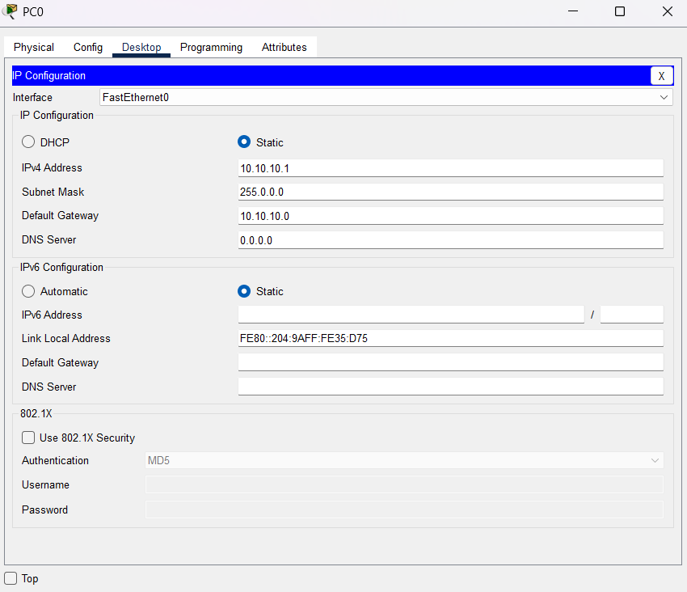

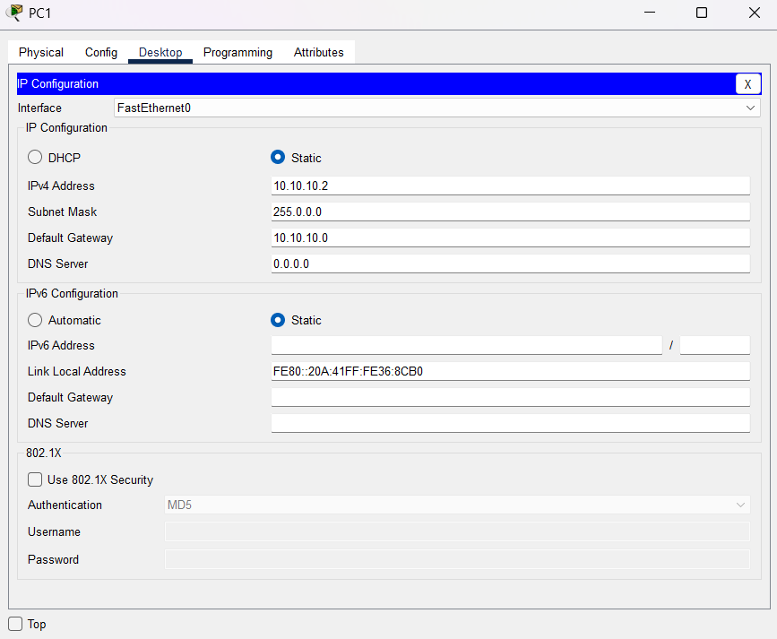
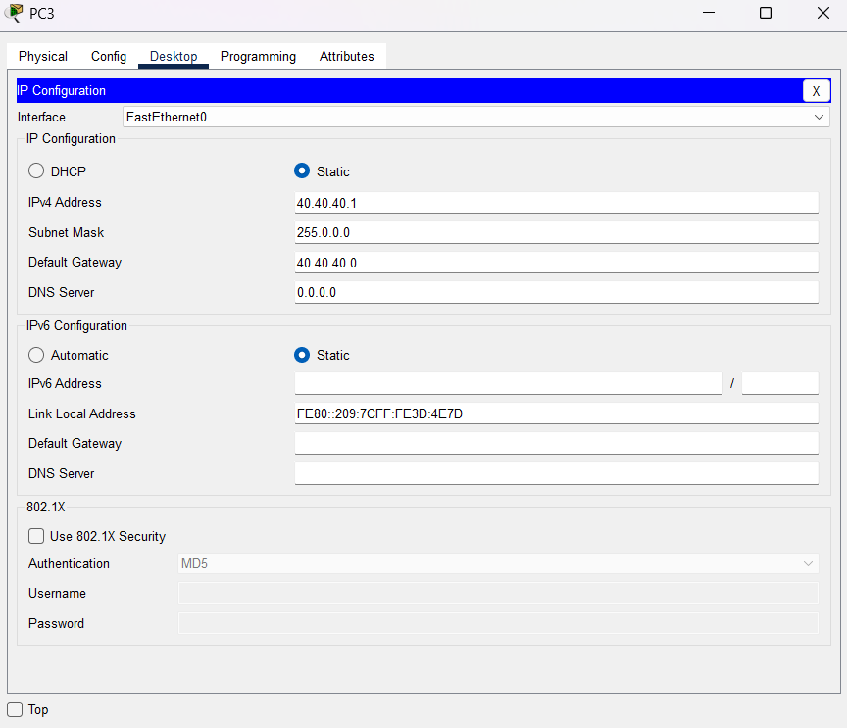
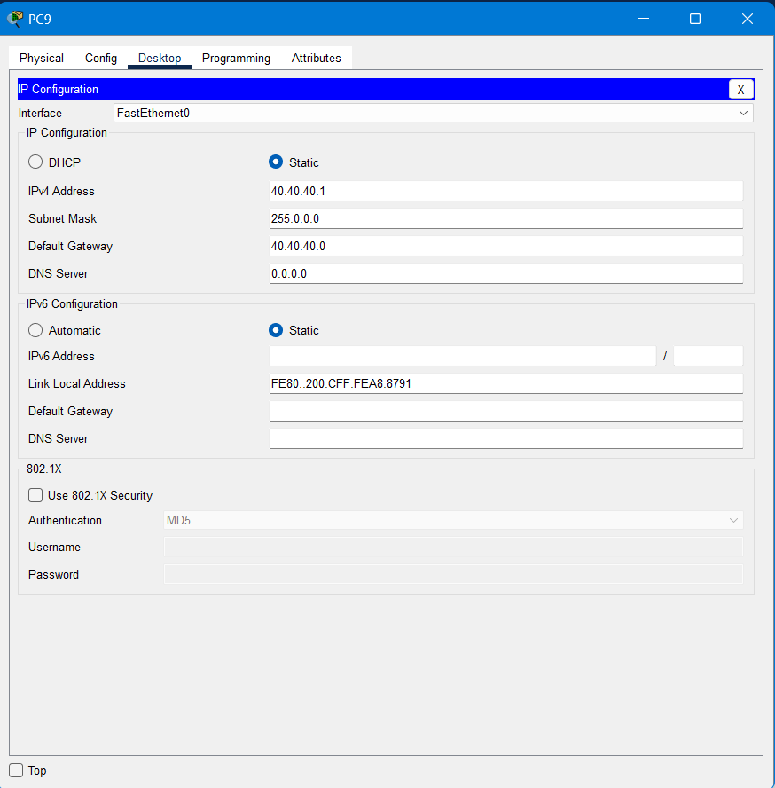
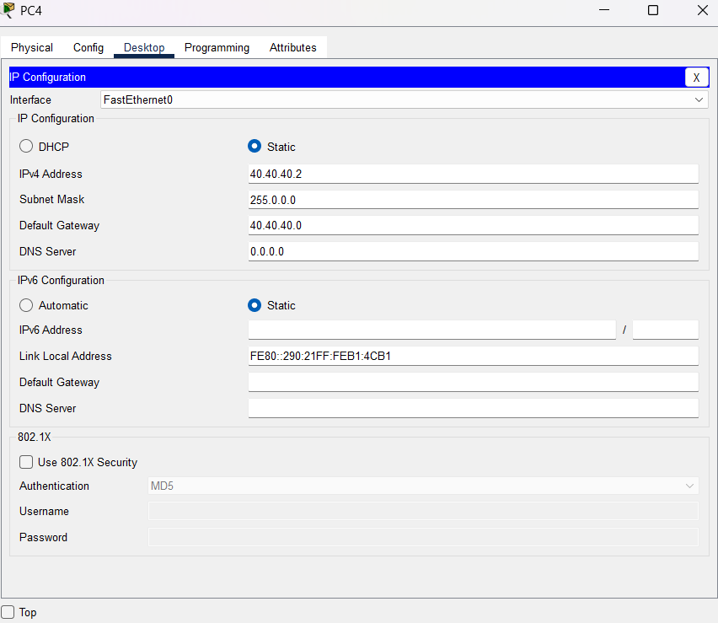
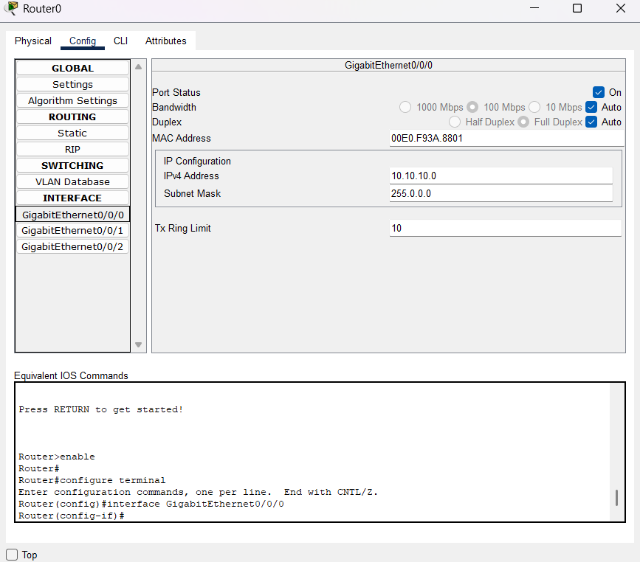

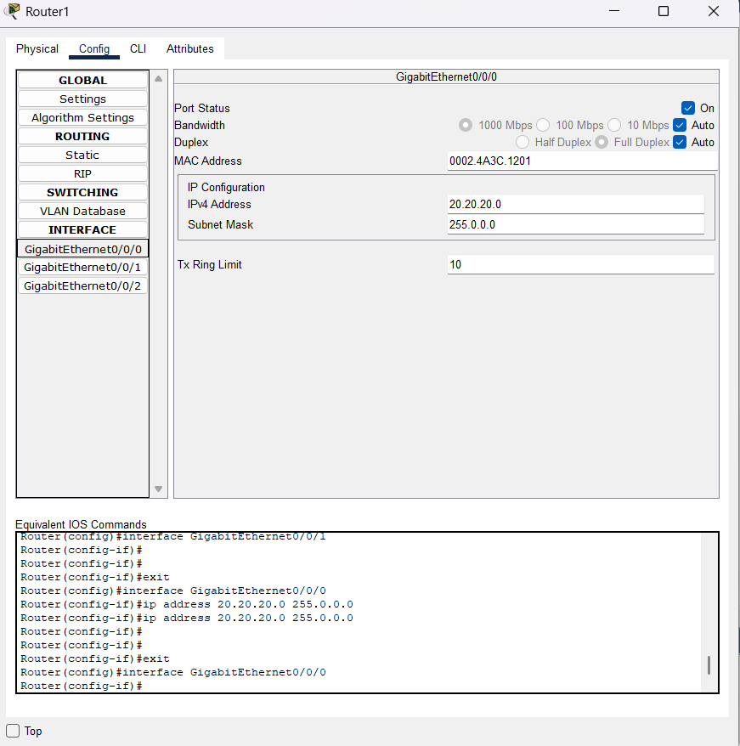

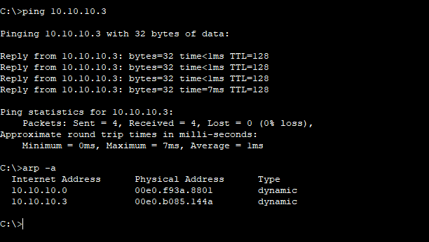

Conclusion : -

The chosen hub-and-spoke topology using MPLS for the WAN, combined with a three-tier hierarchical model for the LANs, proved to be an effective architecture. The implementation of VLANs and a structured IP subnetting scheme was crucial for segmenting traffic, which enhances both security and network performance by isolating broadcast domains for different departments like Sales, HR, and Engineering.

Q & A: -
Q1. What type of network architecture is best for a company with multiple branches?
A: A hierarchical network combining LANs and WANs.
Q2. How are departments within the same branch isolated yet connected?
A: Using VLANs (Virtual LANs) on switches.
Q3. Which device is primarily responsible for inter-branch communication?
A: Routers.
Q4. Why are dynamic routing protocols (like OSPF or BGP) important in such networks?
A: They automatically find the best paths and provide redundancy.

